Discontinuous Gel Electrophoresis

Review from Last Class

When the current is turned on, the Gly/Cl⁻ boundary moves downward through the sample buffer and into the stacking gel. The boundary gradually ‘brings the protein-SDS complexes into the boundary.’ This will form sharp discs of each protein species. Once the stacking process is complete (the protein bands should now be about a few microns in thickness and are located at the end of the stacking gel), the proteins enter the separating gel. The latter has a higher percentage in acrylamide and higher pH than the stacking gel. As a result, the effective mobility of glycine increases due to the higher pH and the effective mobility of the proteins decreases because the separating highly retards these molecules while having little effect on glycine. In the separating gel, the proteins now move in the glycine zone with velocity proportional to their effective mobility. At the end of the run, the observed protein bands will be broader than the discs formed at the stacking gel due to diffusion in separating gel. (More details on pp.13-14 in Electrophoresis part of the hand-out)

(│m_{eff} (all proteins) │ < │m_{eff} (Gly) │ < │m (Cl⁻) │)

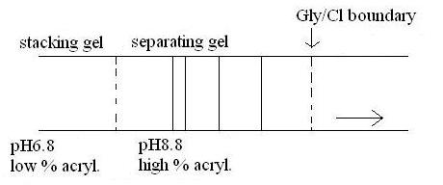
Figure 1. Gel Electrophoresis

About Gels

Why do scientists use gels?

- Because gels can mechanically stabilize gradients, bands, peaks, etc, against mechanical mixing and convection (Convection results when there is a temperature gradient in the gel (of macroscopic size) where there are different temperatures at different zones, which causes the phenomenon of ‘smiling gel.’ Even though it can happen, gels still minimize convection to a degree if other parameters, such as the electrophoresis buffer or the electrophoretic cell, are adjusted.)
- Gels differentially affect the resistance of the ‘medium’ (gel + buffer) to motion of molecules of varying size (as size increases, so does this resistance effect).

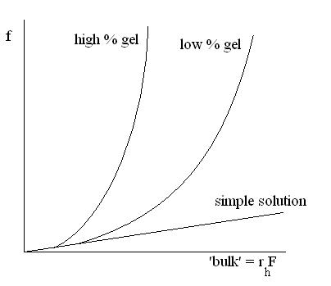
Definition of parameters:

‘bulk’ = r_{h}F, where r_{h} is the hydrated radius and F is the Perrin factor.

f = frictional coefficient

Figure 2. ‘Bulk’ versus Frictional Coefficient

- In a simple solution, the relationship bulk versus f is linear because f = 6πηr_{h}F.
- In a low and high % gel, smaller molecules do not show any retardation at all. However, the bigger, the bulkier the molecules (size, shape, long extended) are, the higher the differential retardation due to the presence of the gel will be.

For macroions, m_{eff} = q_{eff} / f (where m_{eff} and q_{eff} are empirical parameters)

- q_{eff} is unaffected by the presence of the gel. (A gel, on a microscopic level, is simply a continuous solution in which there are occasional strands of polymer ‘sneaking through’. Proteins typically do not even ‘see’ a gel. They only see strands of polymers continuously passing through the liquid medium.)
- f is affected by the presence of the gel

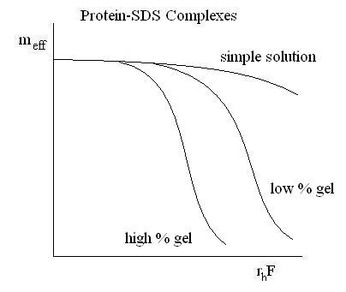
For a series of like macromolecules (double-stranded DNAs, protein-SDS complexes, etc.), q_{eff} and f tend to increase in parallel in simple solutions.
As it can be seen on Figure 3, the curve of m_{eff} versus r_{h}F (bulkiness) is not very steep for a simple solution. There is not much difference in the effective mobility from a small molecule to a bulkier molecule. Therefore, the separation of the molecules will not be very good (low resolution).
A gel makes the frictional coefficient a much more sensitive function of size and shape of molecules.

Figure 3. Effective Mobility versus Bulkiness

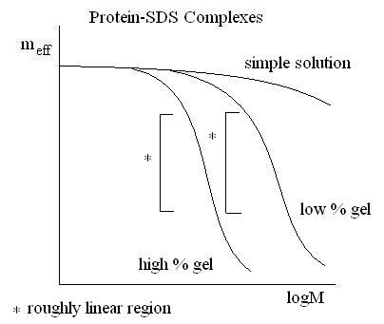
The plot of the effective mobility versus the log of molecular weight shows a roughly linear region for proteins run in a gel. However, there is not perfect linear relationship between these parameters. Even if the experiment went perfect, it would still just be a roughly linear approximation.
The principle is the same for other macromolecules (ds-DNAs in agarose gel, proteins in urea, etc) with some differences (such as the m_{eff} may not necessarily go to zero for big molecules).

Figure 4. Effective Mobility versus log of Molecular Weight

Protein Electrophoresis

Discontinuous Gel Electrophoresis (e.g.: Gly⁻/Cl⁻ based systems. However, it can also be done with other combination of anions with the proper concentrations, proper pH range, etc. It can even be done with different combination of cations, where proteins are complexed with a cationic detergent, etc.). One can run proteins in any of several forms with discontinuous gel electrophoeresis.

- Native (proteins are not denatured): Separation is a function of size, shape, and charge (independent variables for native proteins). Size and shape are involved in the determination of the frictional coefficient. Charge is involved in determining the q_{eff}. Therefore, all three parameters are involved in the determination of the effective mobility (m_{eff} = q_{eff} / f). One must keep in mind that a protein with a larger size does not necessarily have a higher charge than a smaller protein. Likewise, two proteins with the same molecular weight do not necessarily have the same shape or charge. Therefore, sometimes it can be difficult to determine the identity of a separated protein. However, the good thing about native gels is they can give separations on basis of factors other than just size alone. For example, if a scientist wants to separate a few proteins with a molecular weight of 21 kDa, he would not be very successful in doing so with SDS-PAGE, but with a native gel, he may separate/resolve these proteins from each other based on charge, size, and shape.

- Urea-Denatured Proteins: (Secondary, tertiary, and quaternary structures are abolished) Size and shape are systematically related, but charge is not. If the proteins are denatured, it does not mean that the charge has to be uniform. This type of gel can be considered as an intermediate between the native gel and SDS-PAGE. Again, if one cannot separate proteins with SDS-PAGE, one can use the urea-denaturated gel to do so as it has one extra parameter (charge).

- SDS-PAGE: Ideally, molecules become linear (no branches, loops or cross-links), flexible, unstructured (no secondary, tertiary or quaternary structures) chains of uniform (constant) charge/mass ratio because:
  - SDS binds the proteins in a fairly constant SDS / protein mass ratio (~1.4g of SDS / g of protein). The ratio is not perfect, but fairly constant for most proteins and regardless of the composition.
  - The SDS charge >> protein side-chain charges.

In SDS-PAGE, shape (f) and charge (q_{eff}) are direct functions (NOT necessarily linear) of size (M) (see Figure 4).
Shape: If one confers the molecules in a homogeneous family of shape, such ‘open, flexible’ polymers, then the effective shape of a given molecule only depends on its mass.
Charge: SDS charges dominate all the other charges and it binds protein in a fairly constant ratio. Therefore, charge is a direct function of mass.

The above description is for ideal SDS-PAGE only. Polypeptide chains are not all linear. Some of them may have disulfide bonds and one can reduce the amount of dithiothreitol or mercaptoethanol, or even alkylate the cysteines in order to fix the problem. Proteins can be cross-linked, glycosylated (branching), etc. If a protein is glycosylated, SDS may not bind in an ideal charge/mass ratio. Incomplete denaturation by SDS may also occur and it results in that a protein (of 98 kDa for example) may be found at the 78 kDa or 110 kDa. (see p.5 on Electrophoresis part II of the hand-out for a more complete list).

A Concrete Example Using SDS-PAGE

MAPK is a simple transduction kinase. When one of its tyrosine residue is phosphorylated, the MAPK band shifted slightly on the gel, enough to be noticed based on empirical observations. However, why does a small phosphate group (about 2 kDa) display such a shift? The phosphate group is negative, but the SDS charges are overwhelmingly negative. The answer is that the protein was not totally denatured by SDS. This is an example of a non-ideal SDS-PAGE as the protein was not totally unstructured, not totally flexible. The shape of the protein was enough a factor to affect the effective mobility and make a detectable shift on the gel.

Isoelectric Focusing (See p.5 of Electrophoresis Part II of the hand-out)

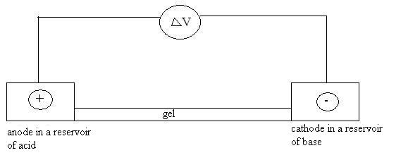
Figure 5. Initial Configuration of Isoelectric Focusing

In isoelectric focusing (IEF), the gel is made of low % acrylamide or agarose for mechanical stabilization only because retardation of the proteins or separation by molecular weight is not desired. IEF separates the proteins based on charges and specifically based on the isolectric point. The initial setup has an anode in a reservoir of acid (e.g.: 0.1 M of HCl or 0.1M of acetate) and a cathode in a reservoir of base.
At the beginning of the run, the anode side has a pH of 2~3 and the cathode side has a pH of 9~10. There is some kind of pH gradient across the gel. A molecule with a negative charge (above its pI) will move toward the anode, heading toward the acidic end of the gel. Likewise, a molecule with a positive charge (below its pI) will move toward the cathode, heading toward the basic end of the gel. A protein moving toward an end of the gel is being titrated. As a result, it will not run off the gel, but instead ‘go and find’ a stable region along the gel, where they can ‘band’ sharply.
***

